Sherman Firefly
23
MILITARY
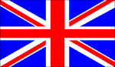
2nd BRIT
AIR POWER
JABOS: +1 2nd BRIT
RESOURCES
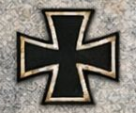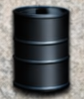
Gain 1 Gain 1

ORDERS: 2 Actions
+1 Attack Strength 2nd BRIT ARMY
The Sherman Firefly was the British variant of the American Sherman tank, fitted with the powerful British 17 pounder anti-tank gun as its main weapon. Originally conceived as a stopgap until future British tank designs came into service, the Sherman Firefly became the most common vehicle with the 17 pounder in World War II. It soon became highly valued as the only British tank capable of defeating the Panther and Tiger tanks it faced in Normandy at standard combat ranges

